**PROGRAM 6**

**AIM :** i) Write the HTML code to add a link on the text “Click here” when you click on this link, open the following website:

www.chitkara.edu.in

ii) Insert an image in an HTML file. When you click on that image, open the following website:

www.google.com

Also write a program illustrating the use of various image tag attributes.

**CODE :**

**(i)**

<html>

<body>

<a href="http://www.chitkara.edu.in">click here</a>

</body>

</html>

**(ii)**

<html>

<body>

<a href="https://www.google.com"><img border=8 height=300 width=500 src="C:\Users\lavish\Downloads\SHAREit\1.jpg"></a>

</body>

</html>

**OUTPUT :**

**(i)**

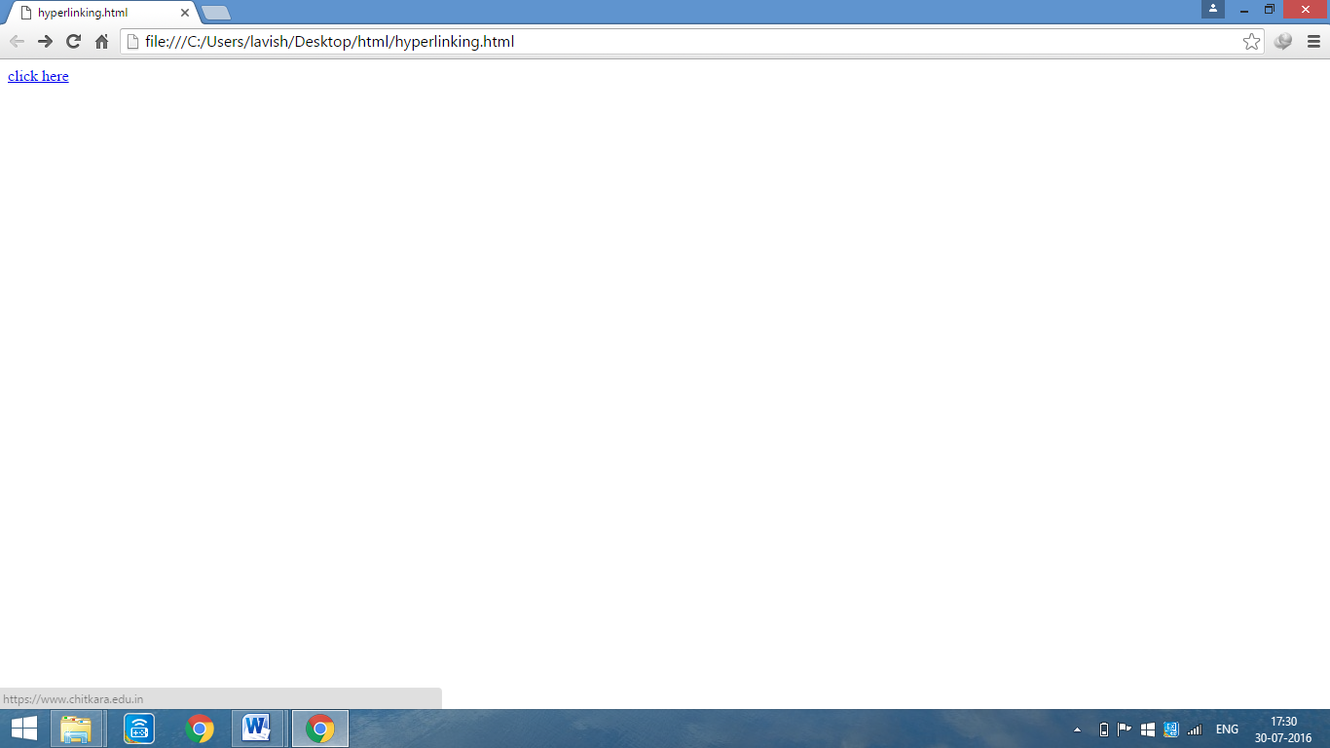

**(ii)**

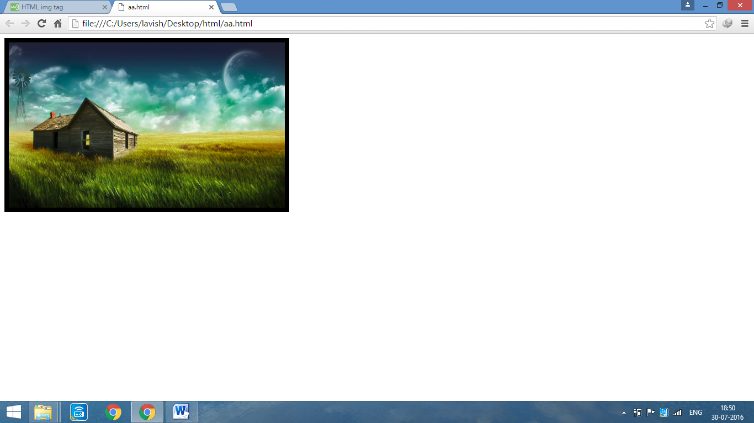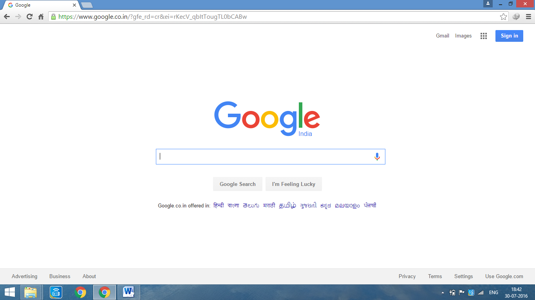

**PROGRAM 7**

**AIM :** Write a HTML code to Jump to another part of a document (On the same page).

**CODE :**

<html>

<head>

<title>wikipedia</title>

</head>

<body link=black alink=yellow vlink=green>

<a name="top"/>

<h1 align=center>Wikipedia</h1>

Learie Constantine (1901–1971) was a West Indian cricketer, lawyer ------------------------------------------------------------------and every one of us needs to understand our all mistakes, causes of pollution, ways to

solve the problems created by it and most importantly how to stop the negative

environmental changes and environmental pollution.</br>

&nbsp;&nbsp;&nbsp;&nbsp;&nbsp;&nbsp;&nbsp;&nbsp;&nbsp;&nbsp;<font color=blue size=5><a

href="#top">TOP</a></font>

</body>

</html>

**OUTPUT :**

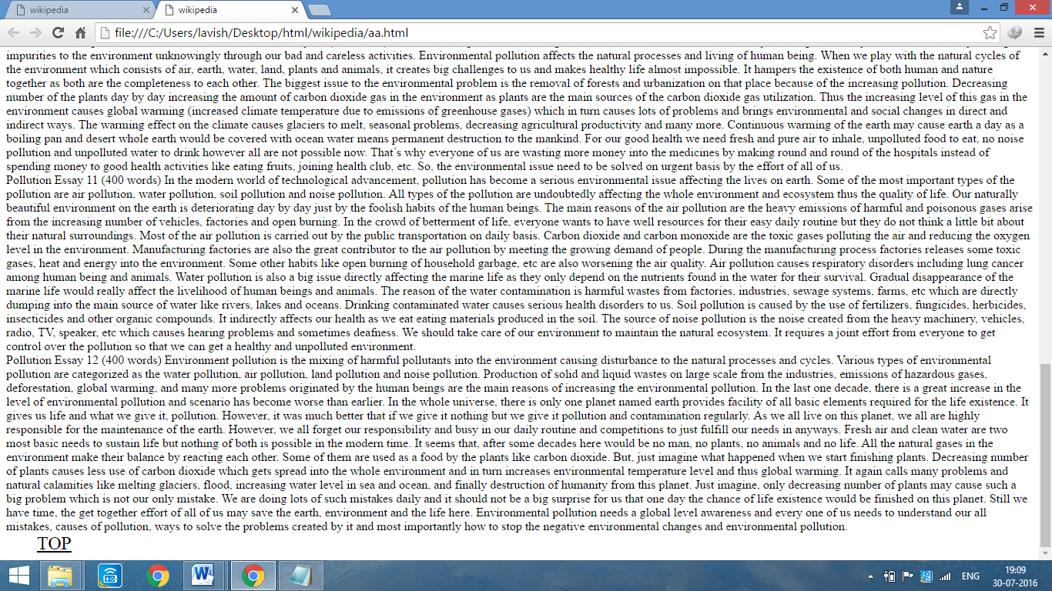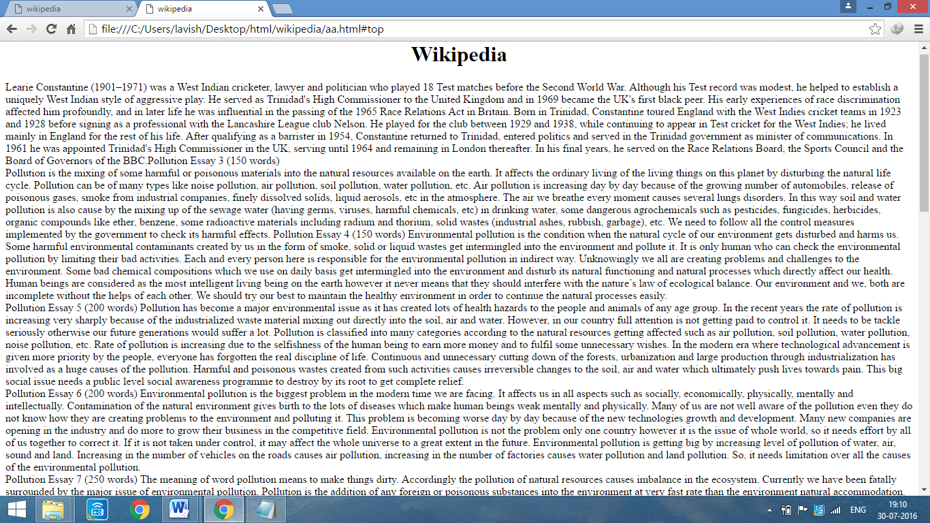

**PROGRAM 8**

**AIM :** Create a document with two links to an external document. The first link should lead to the beginning of the external document. The second link should lead to a particular section in the external document.

**CODE :**

<html>

<head>

<title>wikipedia</title>

</head>

<body link=black alink=yellow vlink=green>

<a name="top"/>

<ul type=circle>

<li><a href="C:\Users\lavish\Desktop\html\wikipedia\chapter1.html">Chapter 1</a>

<ol type=I>

<li><a href="C:\Users\lavish\Desktop\html\wikipedia\chapter1.html#topic 1.1">Topic 1.1</a>

<li><a href="C:\Users\lavish\Desktop\html\wikipedia\chapter1.html#topic 1.2">Topic 1.2</a>

</ol>

<li><a href="chapter2.html">Chapter 2</a>

<ol type=I start=3>

<li><a href="C:\Users\lavish\Desktop\html\wikipedia\chapter2.html#topic 2.1">Topic 2.1</a>

<li><a href="C:\Users\lavish\Desktop\html\wikipedia\chapter2.html#topic 2.2">Topic 2.2</a>

<ol type=A>

<li><a href="topic 2.2.1.html">Topic 2.2.1</a>

<li><a href="topic 2.2.2.html">Topic 2.2.2</a>

</ol>

<li><a href="topic 2.5.html">Topic 2.5</a>

</ol>

<li><a href="chapter3.html">Chapter 3</a>

<li><a href="chapter4.html">Chapter 4</a>

</ul>

Learie Constantine (1901–1971) was a West Indian cricketer, lawyer ------------------------------------------------------------------------------ways to solve the problems created by it and most importantly how to stop the negative environmental changes and environmental pollution.</br>

&nbsp;&nbsp;&nbsp;&nbsp;&nbsp;&nbsp;&nbsp;&nbsp;&nbsp;&nbsp;<font color=blue size=5><a href="#top">TOP</a></font>

</body>

</html>

**Chapter1.html**

<html>

<head>

<title>Chapter 1</title>

<body>

<h1 align=center>Chapter 1</h1>

<a name="topic 1.1"/>

<h2>Topic 1.1</h2>

Learie Constantine (1901–1971) was a West Indian cricketer--------------------------------freeness of doing anything lead them towards serious degradation.</br>

<a name="topic 1.2"/>

<h2>Topic 1.2</h2>

Pollution Essay 8 (250 words) Earth is considered as --------------------------------------- the negative environmental changes and environmental pollution.</br>

</body>

</html>

**OUTPUT**

**:** 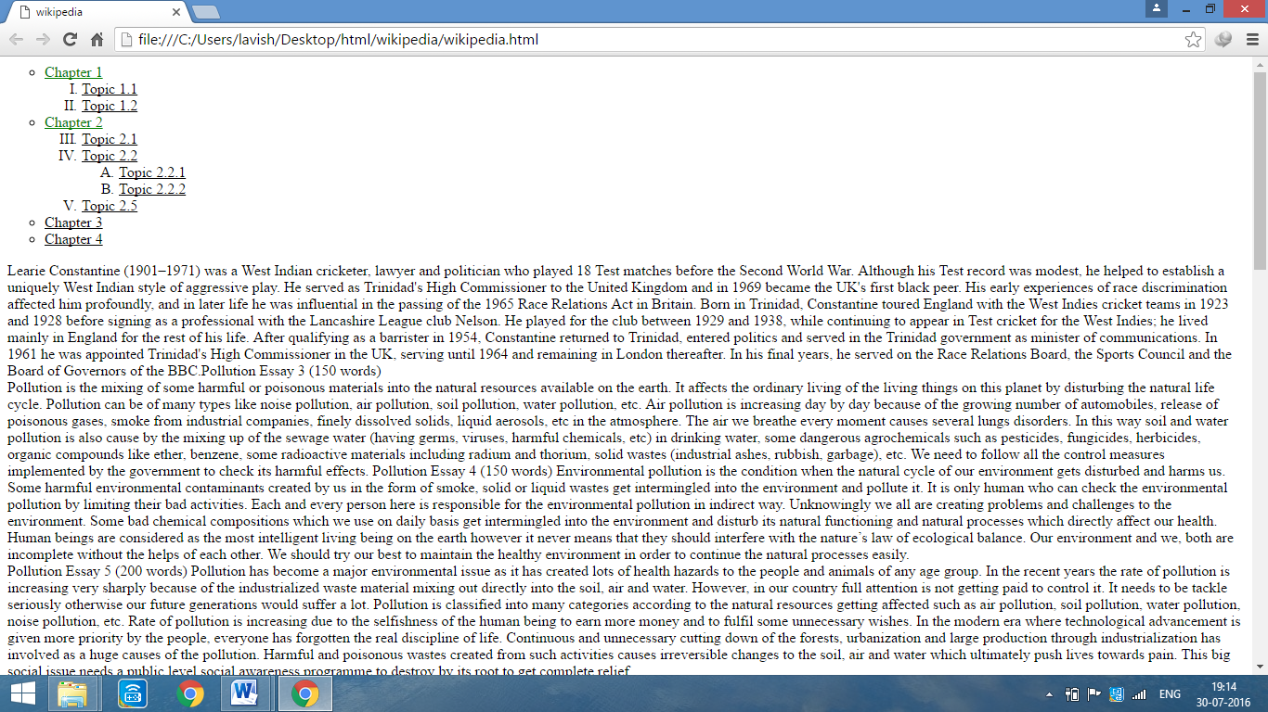

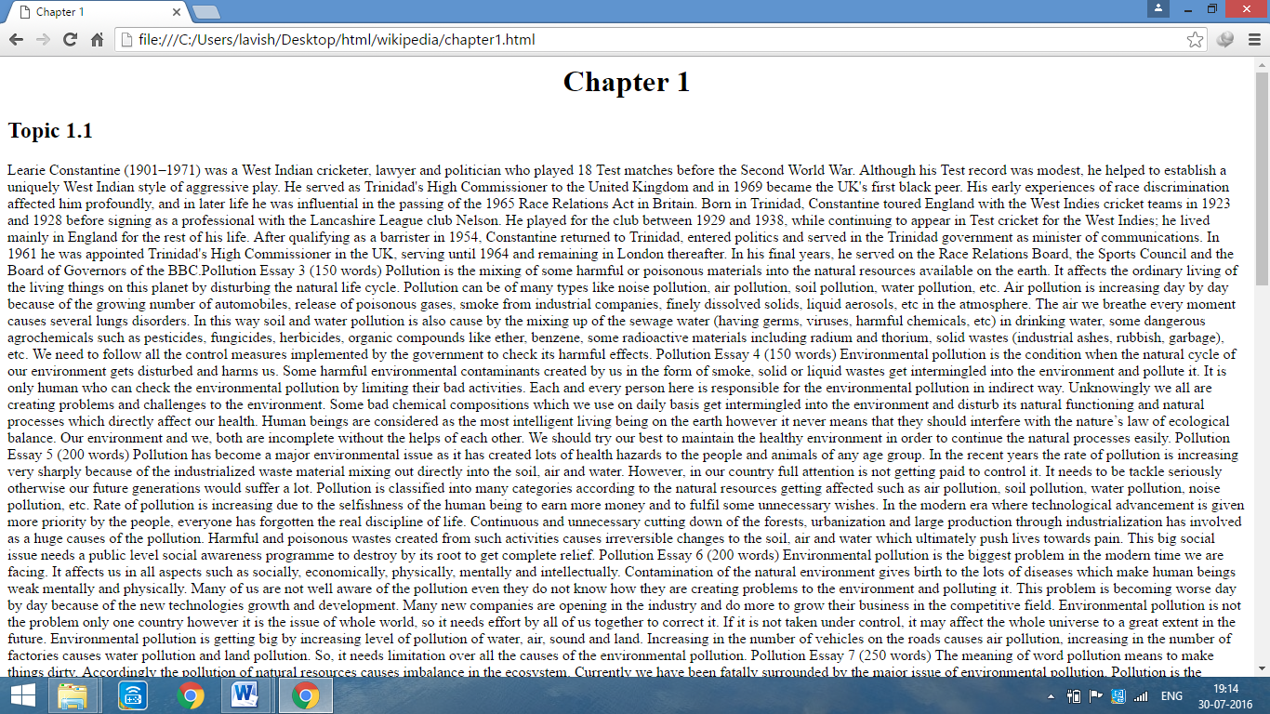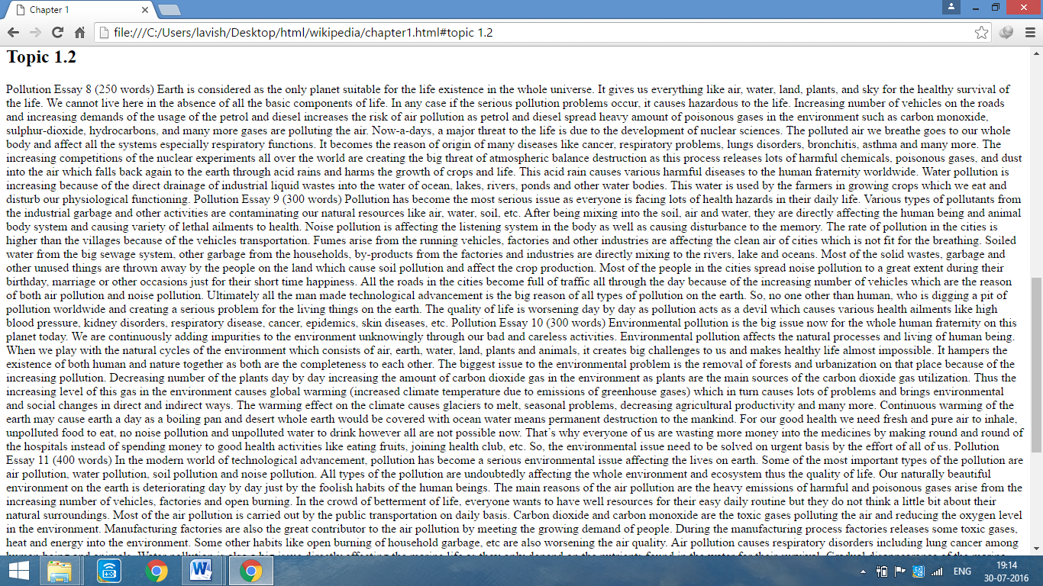

**PROGRAM 9**

**AIM :** Create an image-map, with clickable regions.

**CODE :**

<html>

<head>

<title>sitemap</title>

</head>

<body>

<map name="abc">

<a href="C:\Users\lavish\Desktop\html\1.html"><area shape="rect" coords=0,0,100,100"></a>

<a href="C:\Users\lavish\Desktop\html\2.html"><area shape="circle" coords="300,150,100"></a>

</map>

<center><img height=500 width=700 src="C:\Users\lavish\Downloads\SHAREit\1.jpg" usemap="#abc"/></center>

</body>

</html>

**OUTPUT :**

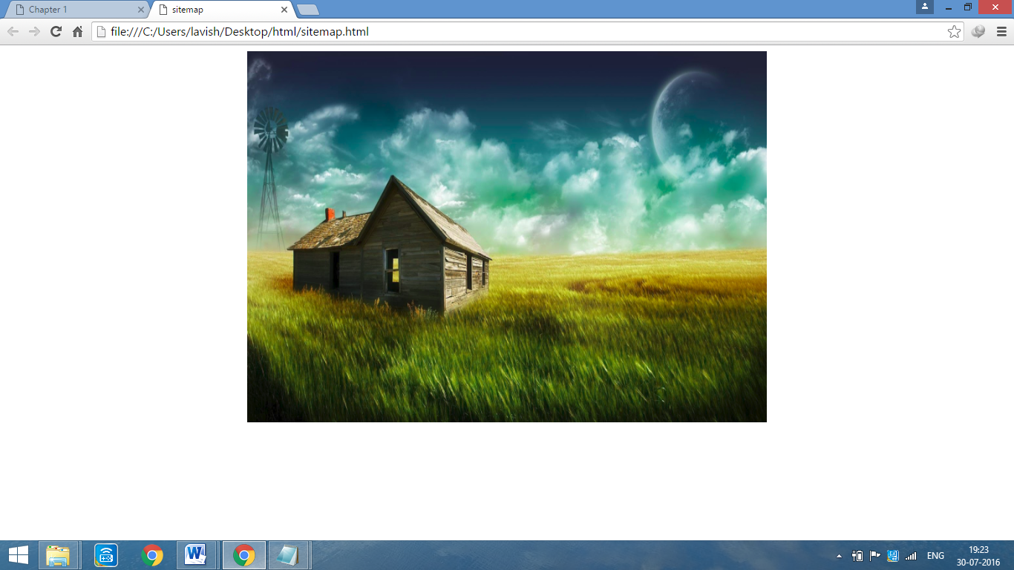

**Region 1 hyperlink**

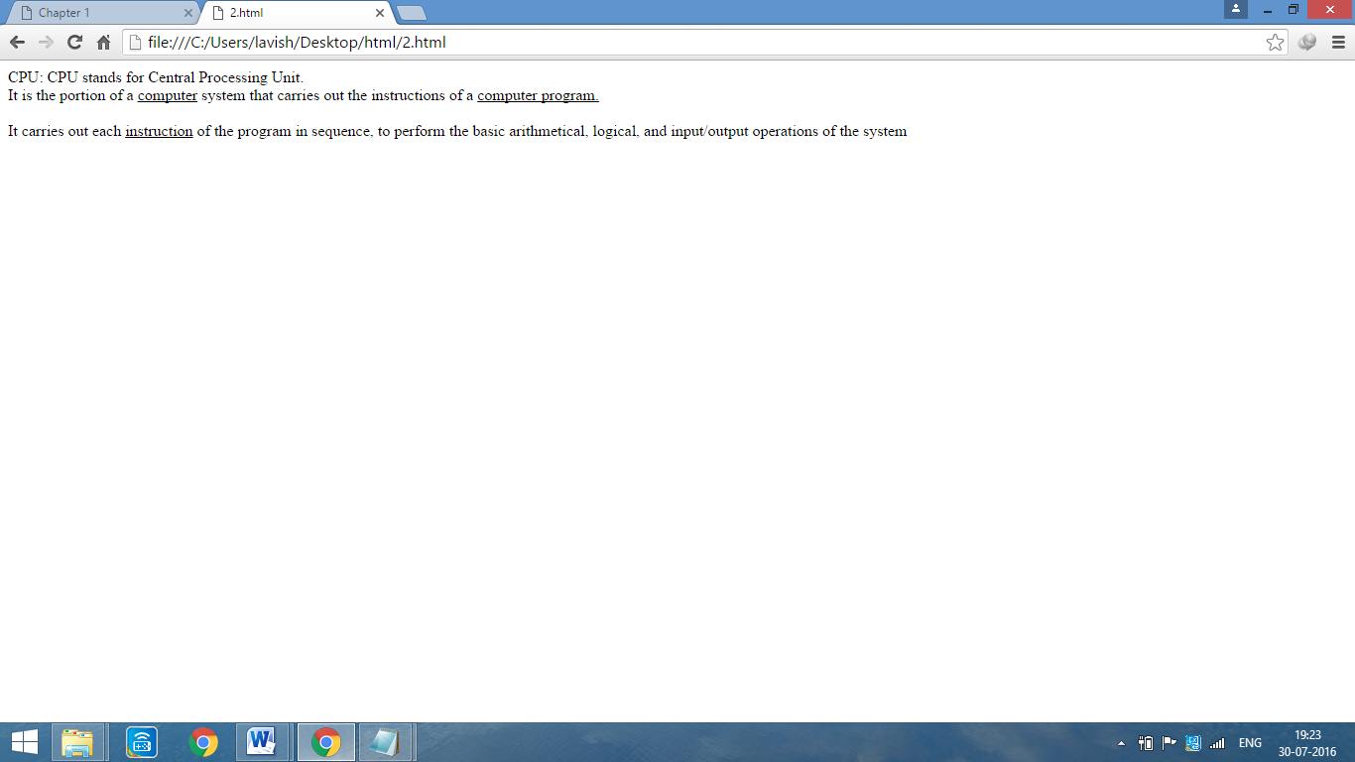

**Region 2 hyperlink**



**PROGRAM 10**

**AIM :** i) Write HTML code for the following table :

|  |  |  |  |
| --- | --- | --- | --- |
| S.No. | Particulars | No. of Items | Price |
| 1. | Hard Disks | 2 | 4000.00 |
| 2. | Monitors | 3 | 15000.00 |
| 3. | CD ROM | 2 | 1000.00 |
| 4. | DVD Writer | 4 | 6000.00 |

ii) Write HTML code for the following table:

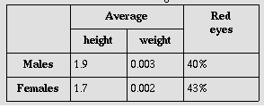

**CODE :**

**(i)**

<html>

<body>

<table border=1 cellpadding=5 cellspacing=0>

<tr><td>S.No.</td><td width=70>Particuars</td><td>No. of items</td><td width=110>Price</td></tr>

<tr><td>1</td><td width=200>Hard Disks</td><td>2</td><td width=110>4000.00</td></tr>

<tr><td>2</td><td width=200>Monitors</td><td>3</td><td width=110>15000.00</td></tr>

<tr><td>3</td><td width=200>CD ROM</td><td>2</td><td width=110>1000.00</td></tr>

<tr><td>4</td><td width=200>DVD Writer</td><td>4</td><td width=110>6000.00</td></tr>

</table>

</body>

</html>

**(ii)**

<html>

<body>

<table border=1 cellpadding=10 cellspacing=0 bgcolor="#D3D3D3">

<tr align=center><td rowspan=2></td><td width=100 colspan=2>Average</td><td rowspan=2>Red ayes</td></tr>

<tr align=center><td width=100>height</td><td width=100>weight</td></tr>

<tr><td>Males</td><td width=100>1.9</td><td width=100>0.003</td><td>40%</td></tr>

<tr><td>Females</td><td width=100>1.7</td><td width=100>0.002</td><td>43%</td></tr>

</table>

</body>

</html>

**OUTPUT :**

**(i)**

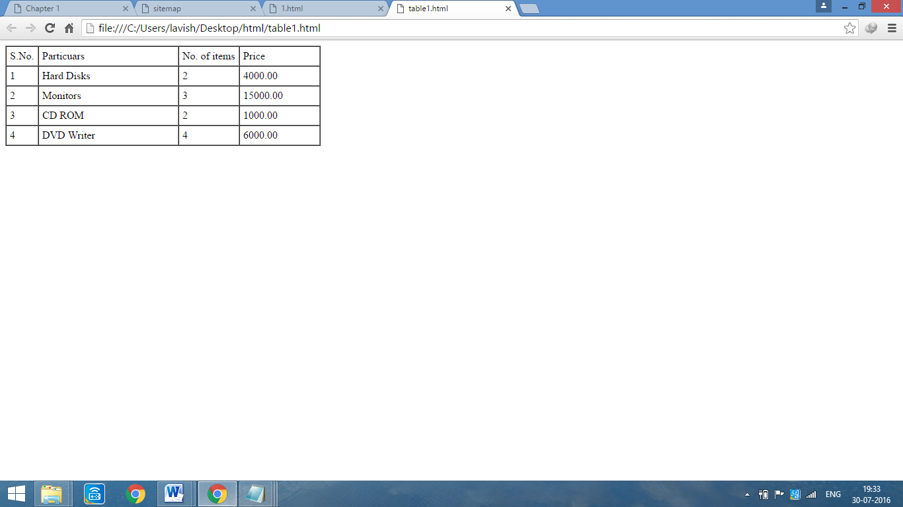

**(ii)**

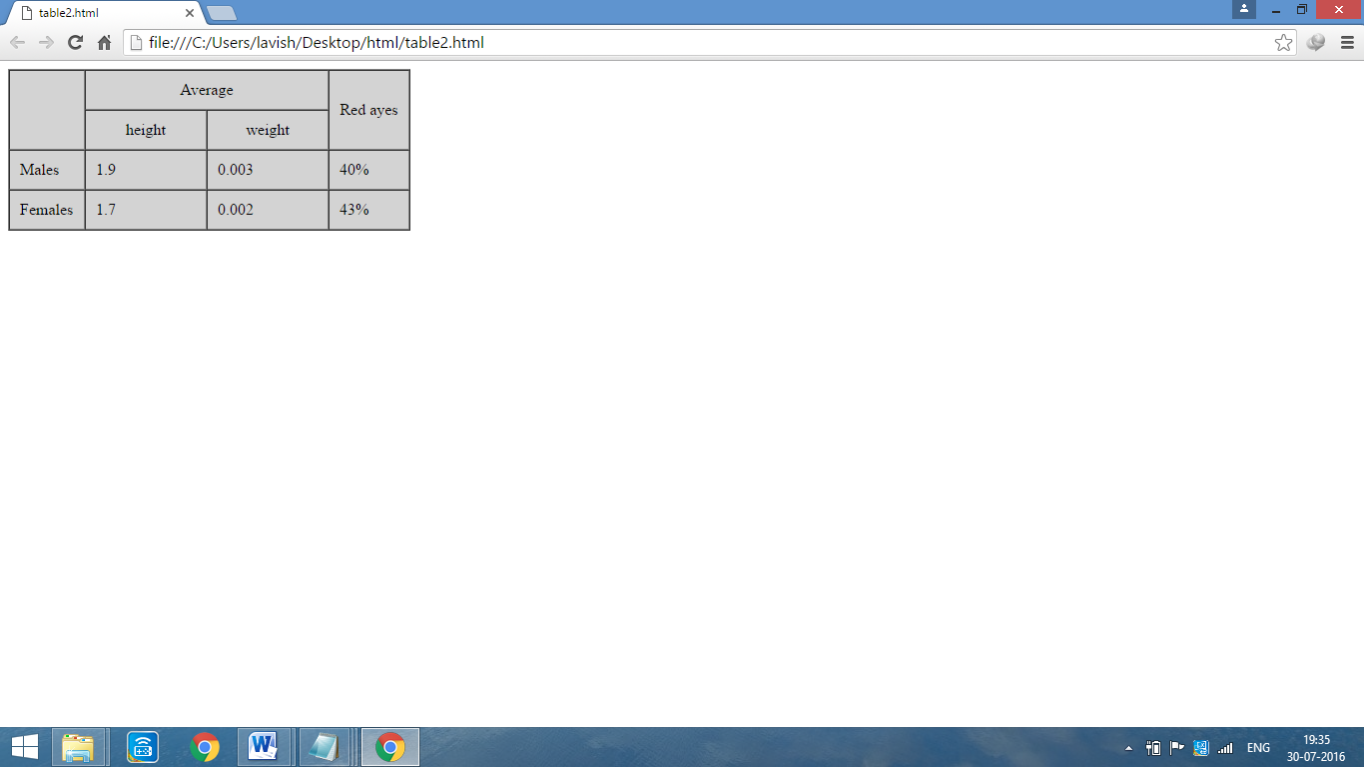

**PROGRAM 11**

**AIM :** Create a table to show your class time-table.

**CODE :**

<html>

<body>

<h1 align=center><font face=calibri size=9>CSE-3F</font></h1>

Chitkara University, Jhansla Distt.Patiala-140401,Punjab

<table border=1 cellpadding=0 cellspacing=0>

<tr height=100><th width=100></th><th width=100 >1</th><th width=100>2</th><th width=100>3</th><th width=100>4</th><th width=100>5</th><th width=100>6</th><th width=100>7</th><th width=100>8</th></tr>

<tr height=50><th rowspan=2>Mo</th><th colspan=2 bgcolor=green>PSTC</th><th rowspan=2 bgcolor=blue>CN</th><th rowspan=2></th><th colspan=2 bgcolor=green>NMST-Lab</th><th colspan=2 bgcolor=blue>CST-Lab</th></tr>

<tr height=50><th colspan=2 bgcolor=pink>CST-Lab</th><th colspan=2 bgcolor=pink>PSTC-Lab</th><th colspan=2 bgcolor=grey>CN-Lab</th>

<tr height=50><th rowspan=2>Tu</th><th colspan=2 bgcolor=green>PSTC-Lab</th><th rowspan=2 bgcolor=grey>CST</th><th rowspan=2></th><th rowspan=2 bgcolor=grey>NMST</th><th rowspan=2></th><th colspan=2 bgcolor=green>CST-Lab</th></tr>

<tr height=50><th colspan=2 bgcolor=pink>CST-Lab</th><th colspan=2 bgcolor=pink>PSTC</th></tr>

<tr height=50><th rowspan=2>We</th><th rowspan=2 bgcolor=blue>CST</th><th rowspan=2 bgcolor=green>NMST</th><th colspan=2 bgcolor=blue>CST-Lab</th><th rowspan=2></th><th rowspan=2 bgcolor=pink>CN</th><th colspan=2 bgcolor=blue>PSTC-Lab</th></tr>

<tr height=50><th colspan=2 bgcolor=grey>PSTC-Lab</th><th colspan=2 bgcolor=green>CN-Lab</th></tr>

<tr height=50><th rowspan=2>Th</th><th rowspan=2 bgcolor=grey>CN</th><th rowspan=2 bgcolor=pink>NMST</th><th colspan=2 bgcolor=blue>CST-Lab</th><th rowspan=2></th><th rowspan=2 bgcolor=grey>CST</th><th colspan=2 bgcolor=blue>PSTC-Lab</th>

<tr height=50><th colspan=2 bgcolor=green>PSTC-Lab</th><th colspan=2 bgcolor=green>NMST-Lab</th></tr>

<tr height=50><th rowspan=2>Fr</th><th rowspan=2 bgcolor=green>CST</th><th bgcolor=blue>Mentoring</th><th colspan=2 bgcolor=grey>CST-Lab</th><th rowspan=2></th><th></th><th colspan=2 bgcolor=pink>PSTC-Lab</th>

<tr height=50><th></th><th colspan=2 bgcolor=green>PSTC-Lab</th><th bgcolor=blue>Mentoring</th><th colspan=2 bgcolor=green>CST-Lab</th></tr>

</table>

</body>

</html>

**OUTPUT :**

